1. Create a new 3D project call it anything you want

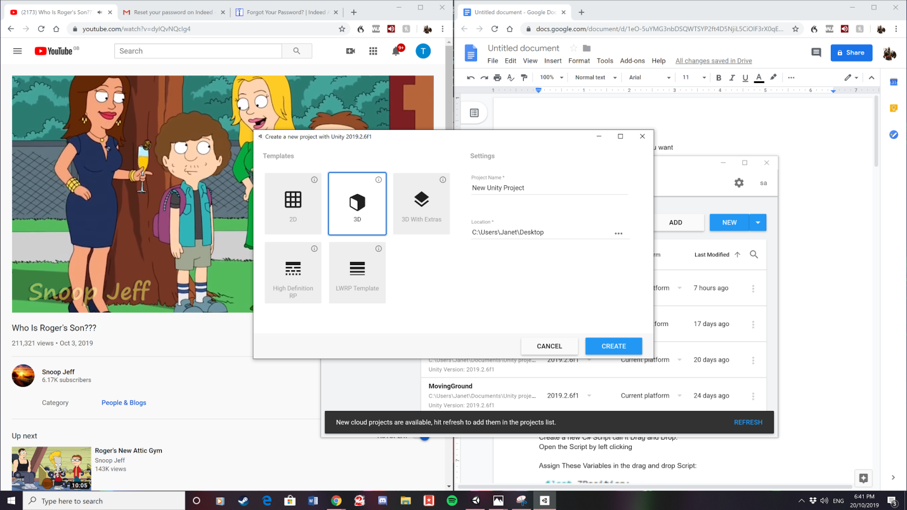

2. Save scene

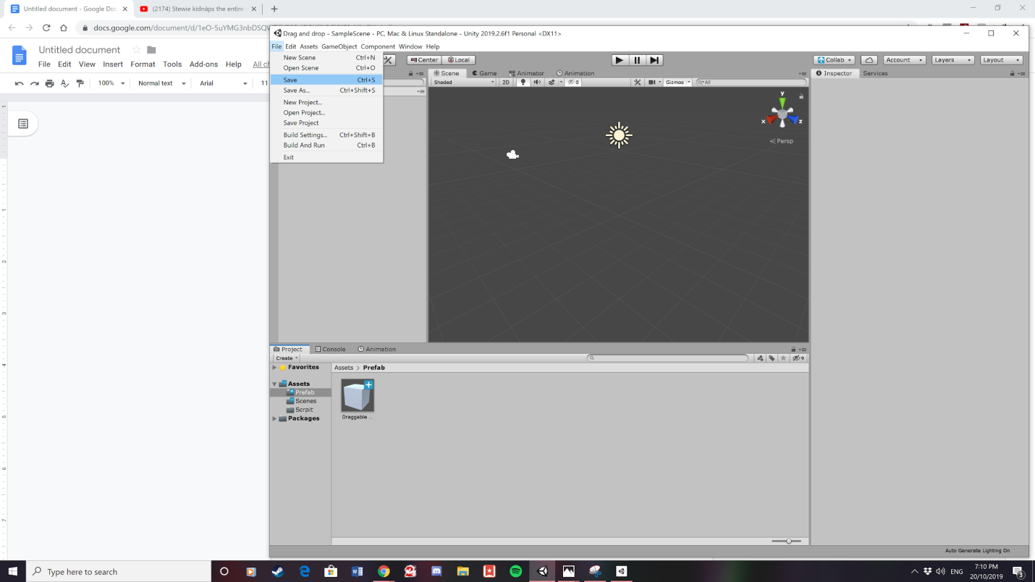

3. Create a cube

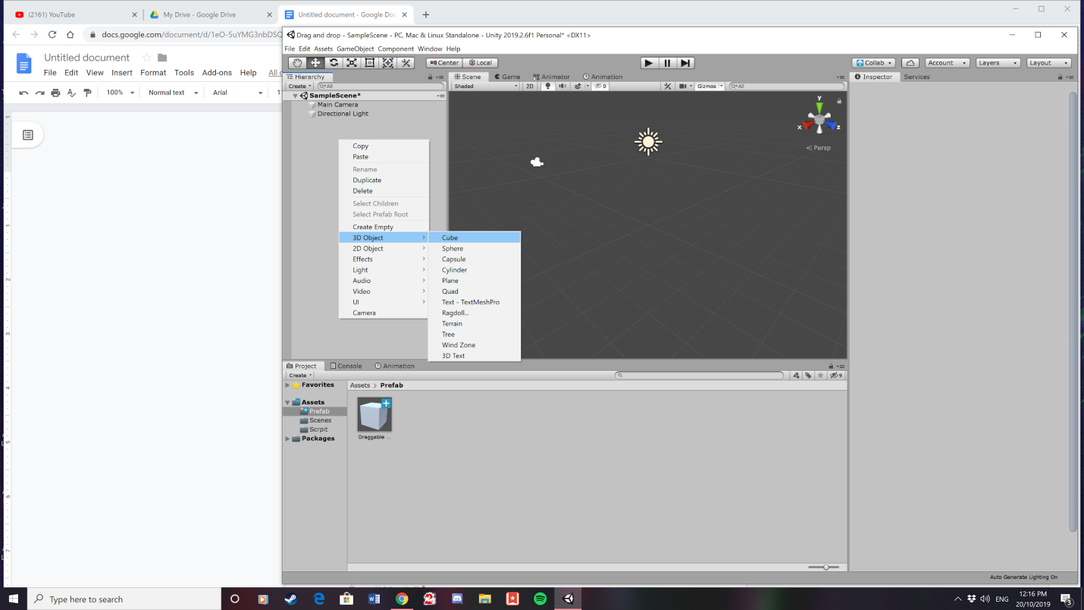

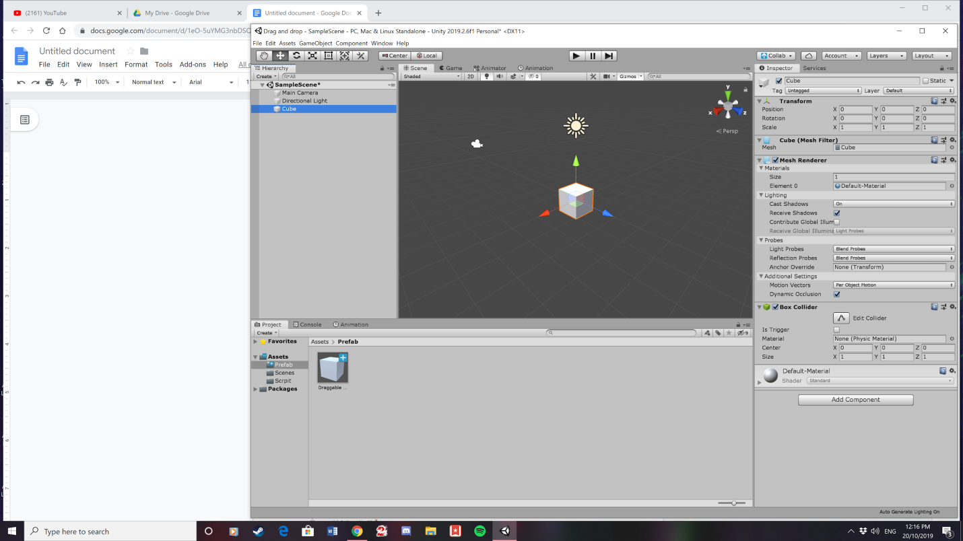

4. Rename the cube to Draggable object

5. Create a folder and call it scripts. To access this menu you need to left click on the bottom of the screen.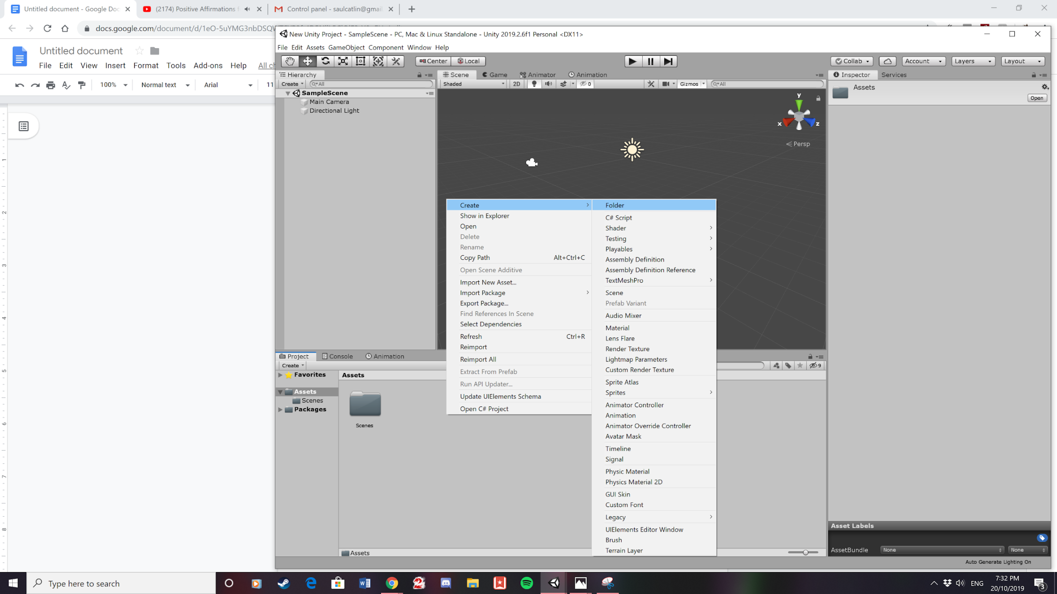

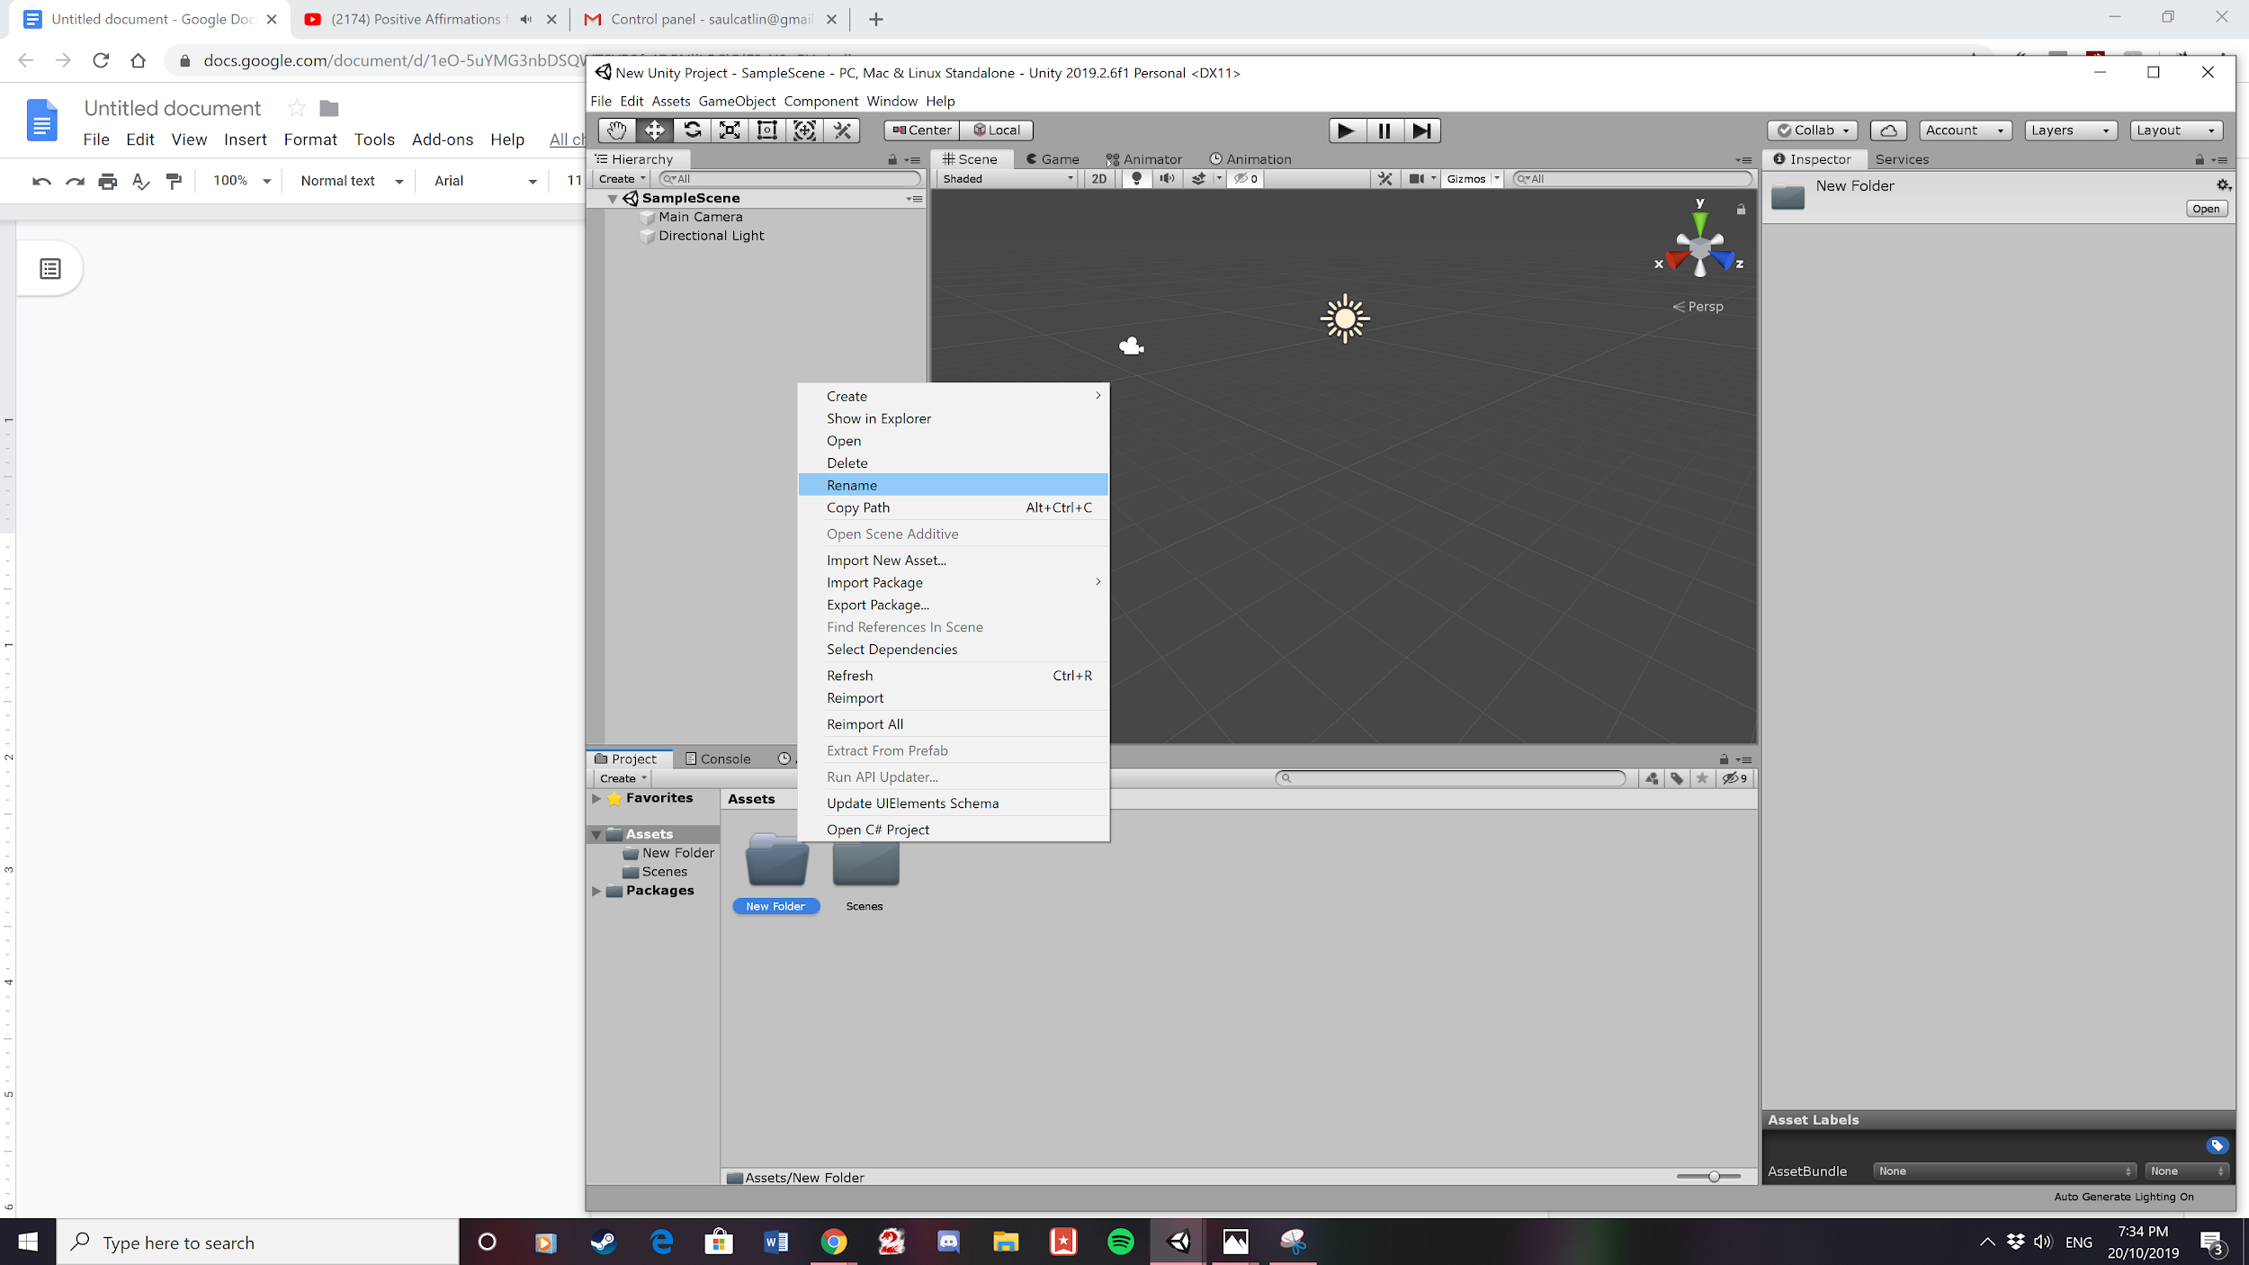

6. Click Rename to call the folder Script to access this menu you need to left click on the Folder.

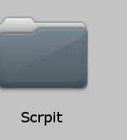

7. Create a new C# Script.

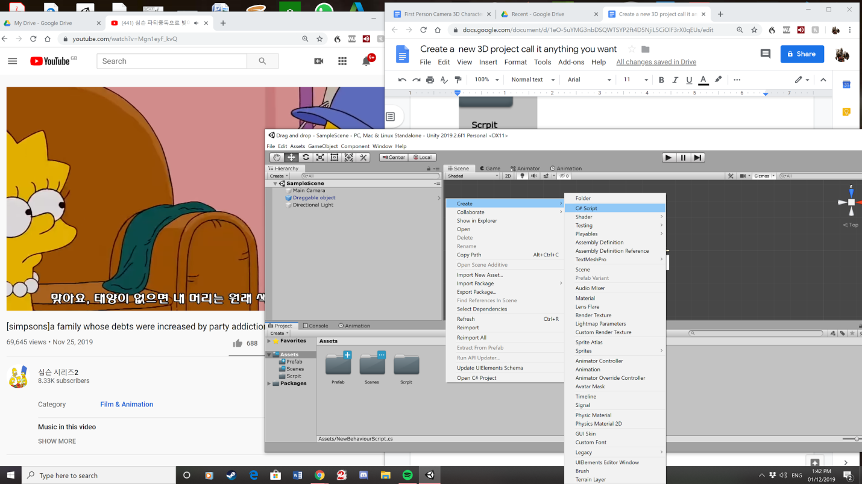

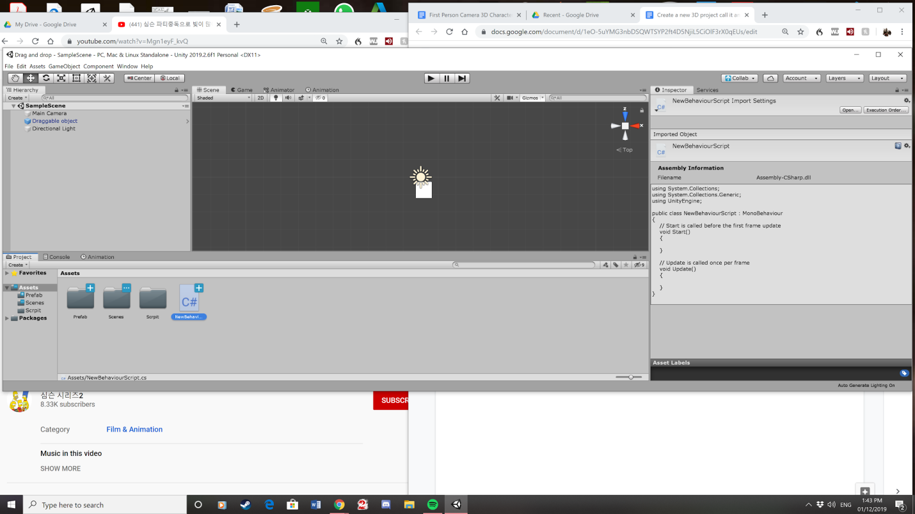

8. Call it drag 3d.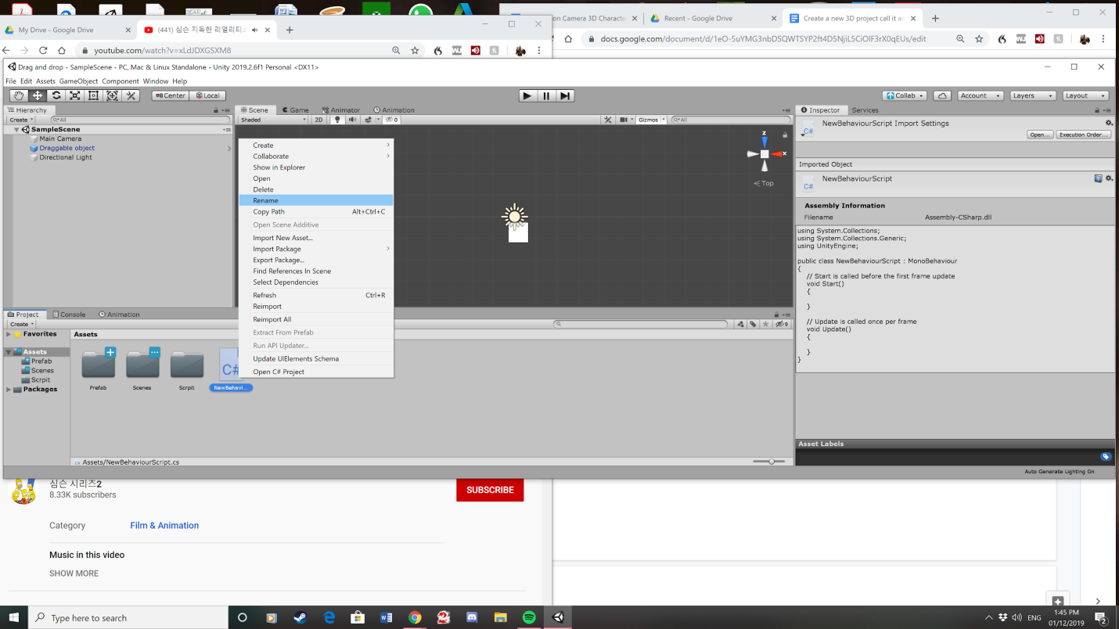

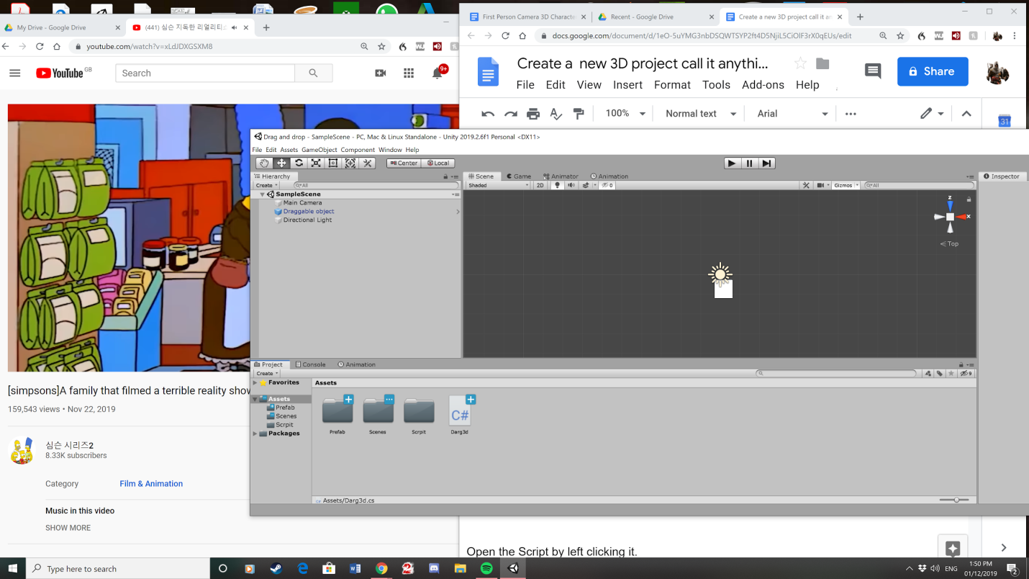

9. Drag script onto Draggable object.

9. Open the Script by left clicking it. This opens visual code

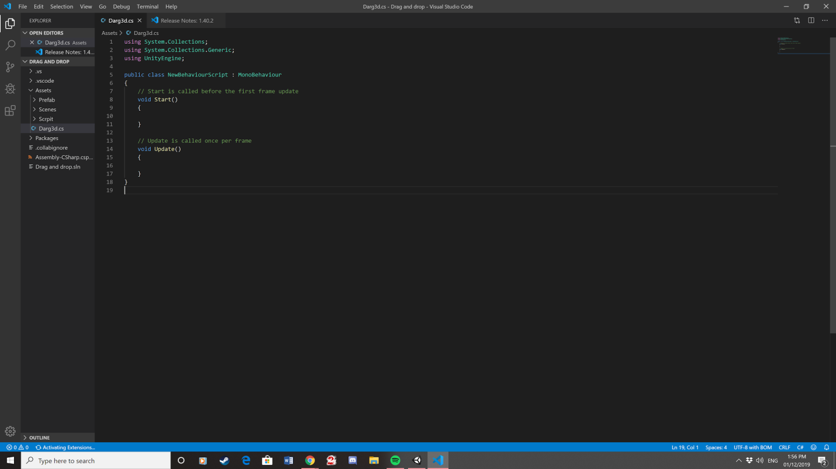

10. Assign These Variables in the drag and drop Script:

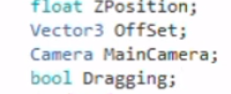

11. Then put this code into the start function in drag and drop Script:

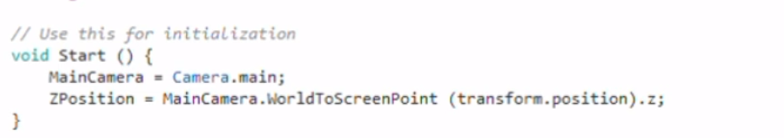

12. Then create void OnMouseDown and OnMouseUp after Void Update.

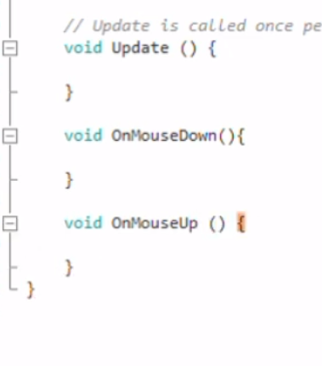

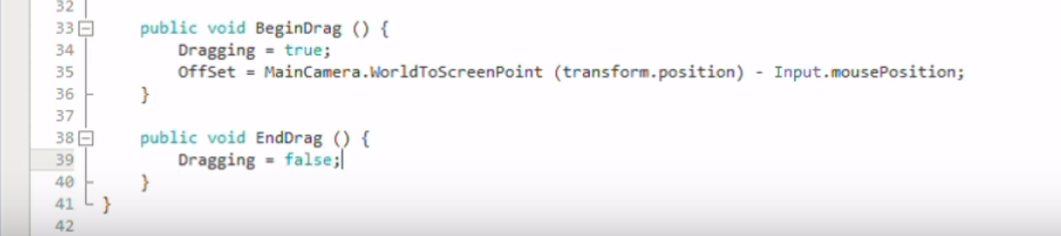

13. Then create public void Begin Drag and public void end drag and input this code:

14. Then add an if statement inside of the mouse down method

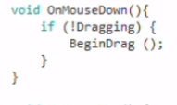

15. After this then add this code into the mouse up method

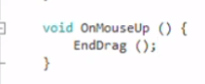

16. Then add if statement to void Update Method

17. Then add these variables under the variables we set at the Start 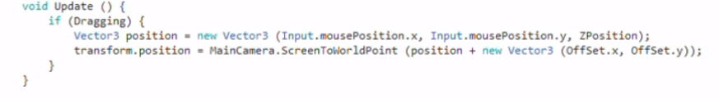

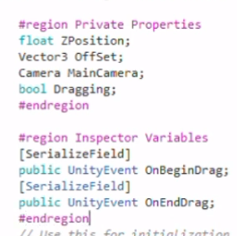

18. Then add into the Begin Drag method

OnBeginDrag.Invoke.

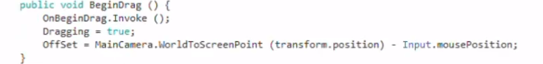

19. Then add into the End Drag method

Add OnEndDrag .Invoke.



20. Then move Camera MainCamera above where SerializeField is. This is placed where the variables are placed. Make sure you set Camera MainCamera to public Camera MainCamera.

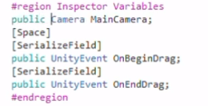

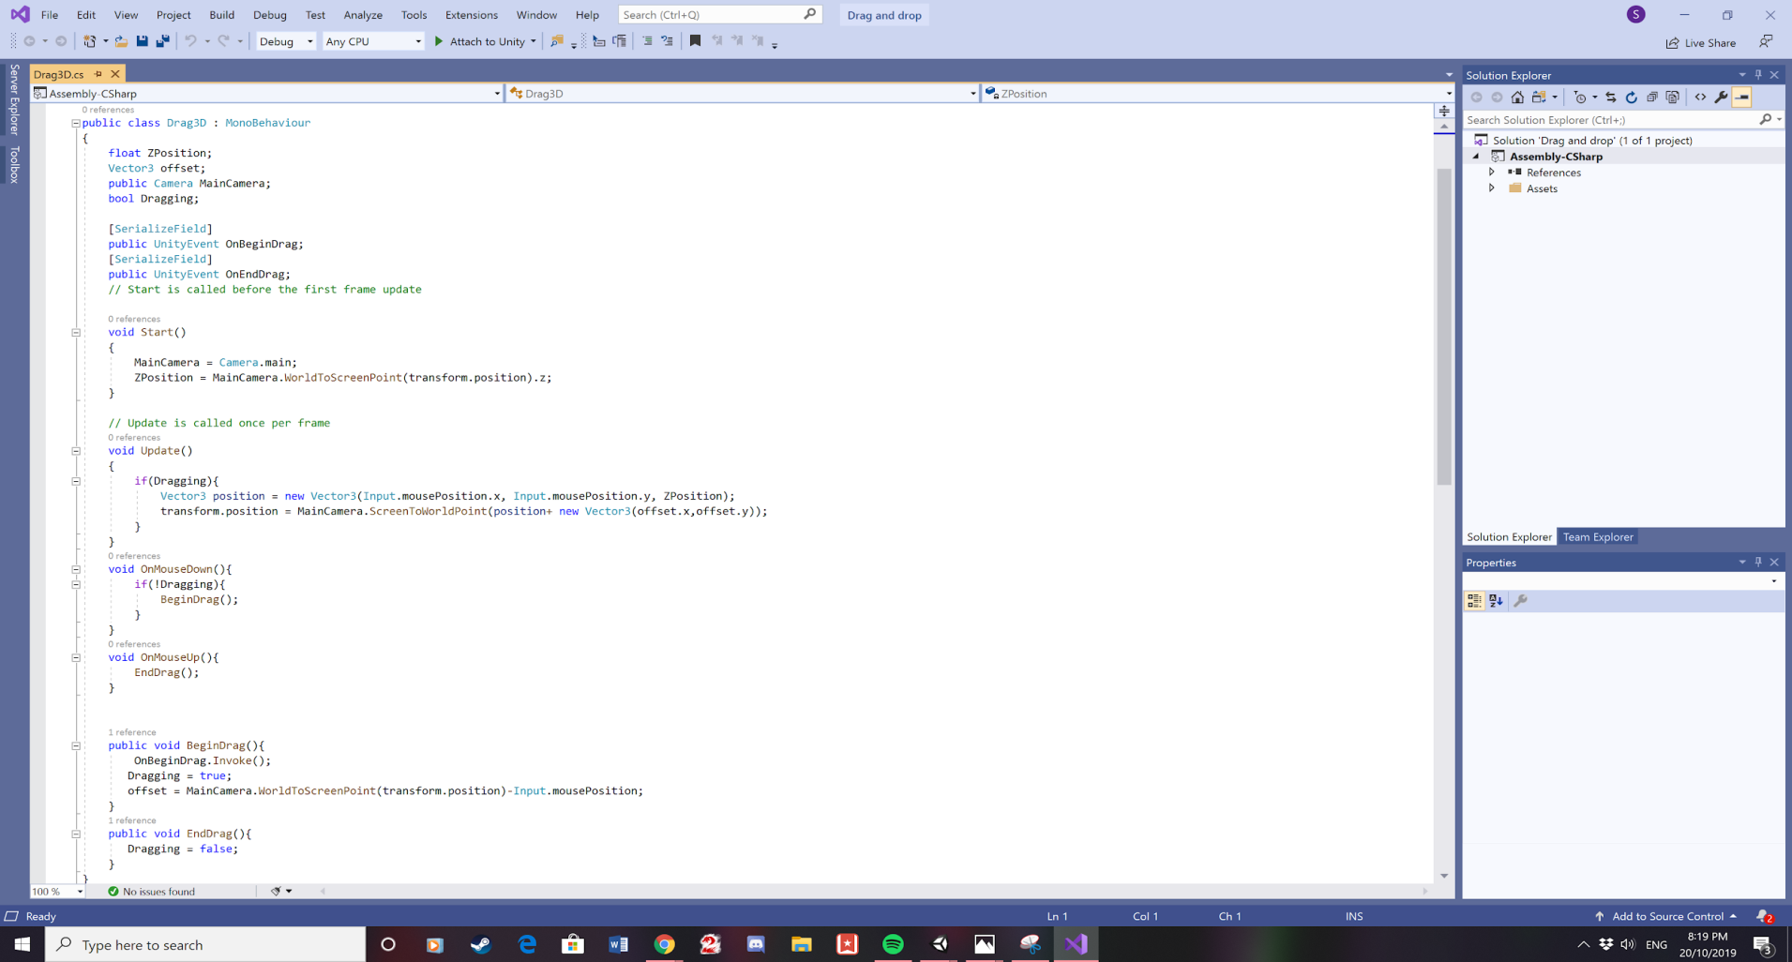21. This what the code should look like

22. Assign main Camera to the Draggable game object. By dragging the main Camera on the game object.

23. Then press the play button. This will allow dragging the cube around the screen when the cube is clicked. 